k,
MARCH NEWSLETTER 2017
CHAPTER 21
411 N. STEPHENS AVE SPRINGFIELD IL. 62702

AIRBORNE MY BROTHERS

MEETINGS
THERE WILL BE A MEETING AT EACH SITE IN MARCH AND APRIL. WE NEED TO MEET TO DISCUSS OFFICERS FOR THE NEXT ( 2 ) YEARS AND HOW THIS CHAPTER WILL GROW IN THE NEXT FIVE YEARS. THIS CHAPTER REALLY NEED ALL OF YOU TO ATTEND THESE MEETINGS, GUYS THIS IS INPORTANT. MAKE THESE MEETINGS, AND THE CHAPTER WILL CONTINUE TO GROW.
MARCH 6TH AT THE VFW ON CHURCH RD IN ARNOLD MO. AT 2.00 PM
MARCH 14TH AT THE VFW 2349 STOCKYARK RD SPRINGFIELD ILL 62702
APRIL 3RD IN ARNOLD MO.
APRIL 11TH IN SPRINGFIELD.
DAN AND I WORKED HARD TO GET THIS CHAPTER STARTED AND WORKING AND WE HAVE HAD GREAT SUCCESS SO FAR,BUT WE NEED ALL OF YOU TO HELP IN ONE WAY OR ANOTHER ATTENDING MEETING IS ONE WAY, DONATION IS ANOTHER BOTH ARE HIGHLY APPRECIATED. OUR TWO BIGGEST DONATORS LIVE 1000 MILES AWAY. COME ON GUYS THIS CHAPTER NEEDS ALL OF YOU.

FUNDRAISER::
WE NEED MEN OR WOMEN TO MAN THE SIT HERE IN SPRINGFIELD IL. MAY 27TH AND 28TH AND OR JULY 1ST AND 2ND BOTH SATURDAYS 9-3 AND SUNDAYS 10-3. WE WILL BE AT THE COUNTRY MARKET ON VETERANS AND WABASH IN SPRINGFIELD IL.
WE LOST THE WALMART IN KIRKWOODS IN THE ST. LOUIS AREA, AND BELIEVE THIS MAY HURT. THE CHAPTER WAS COUNTING ON $2,500.00 TOTAL FROM THE FOUR DAYS THERE, NOW WE WILL NOT HAVE THAT $2,500.00. THAT’S A LOT OF MONEY GUYS WE NEED TO MAKE THAT UP SOME WAY.
YOU GUYS THAT LIVE IN DIFFERENT AREAS, IF YOU CAN GET A STORE TO LET YOU DO IT ON THISE WEEKENDS I WILL SEND YOU THE FLAGS, ANY WEEKEND WILL DO BUT THOSE ARE OUR HOILDAYS AND PEOPLE TEND TO GIVE MORE ON THOSE HOILDAYS.
IF WE CANT MAKE UP THAT LOST REVENUE THE CHAPTER WILL HAVE TO STOP DONATING MONEY TO SOME ORGANIZATIONS, I FOR ONE DON’T WISH TO DO THAT.
REMEMBER GUYS EACH MONTH WE GIVE $173.00 TO ONE FOOD BANK OR THE OTHER THAT IS $2,276.00 A YEAR, WE HAVE OUR SCHOLARSHIP TO GIVE IN MAY THAT IS $1,173.00 AND WE HAVE THE OTHER SMALLER AMOUNTS THAT WE GIVE OUT TO OTHERS WHEN ASK AND NEEDED. WHAT HAPPENS WHEN A CHAPTER MEMBER NEEDS HELP AND WE CAN’T GIVE IT. THAT WOULD BREAK MY HEART?

SPRINGFIELD MEETING; MARCH 14TH
WE HAVE A SPECIAL GUEST COMING TO THE SPRINGFIELD IL. MEETING ON MARCH 14TH. LISA STEPHENS WOULD LIKE TO PRESENT US WITH A PIN FROM THE DAUGHTERS OF THE REVOLUTION. LISA IS THE DISTRICT 6 OFFICER AND NSDAR CHAPTER VICE REGENT.
LISA IS THE WIFE OF CHAPTER MEMBER RON STEPHENS IT WOULD BE GREAT FOR LOTS OF YOU GUYS TO SHOW UP, ALL MO. MEMBERS THAT ATTEND MEETING SHOULD TRY AND BE IN SPRINGFIELD ON MARCH 14TH, AND EVERY HERD MAN IN ILL. SHOULD BE HERE.
IT WILL BE A HONOR TO ACCEPT THESE PINS FROM THE DAUGHTERS OF THE REVOLUTION. PLEASE LET ME KNOW IF YOU PLAN TO ATTEND THIS MEETING, LISA NEEDS TO KNOW THE NUMBER OF PINS TO HAVE BEFORE HAND.

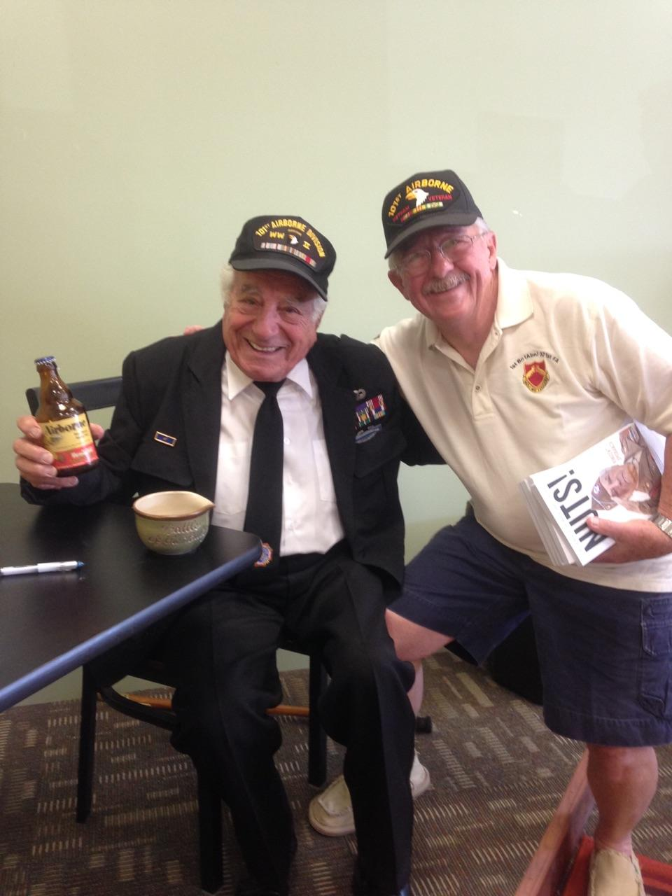REMEMBER THE EMAIL I SENT OUT ON BASTOGUE BATTLE OF THE BULGE AND THE (AIRBORNE) BEER
THIS IS THE GUY IN THE VIDEO VINCE WITH OUR OWN CHAPTER MEMBER JIM TAYLOR AT A BOOK SIGNING HERE IN SPRINGFIELD IL LAST YEAR.

OK GUYS TRY HARD TO BE AT THESE MEETING WE WILL BE ELECTING OFFICERS

REMEMBER THE SPECIAL MEETING IN SPRINGFIELD ON THE 14TH OF MARCH
MEETING LOCATION VFW IN ARNOLD MO. ON CHURCH RD.
IN SPRINGFIELD IL VFW 2349 STOCKYARD RD. 62702
21 OUT

